**Data science Project**

1. ***Introduction***
   1. ***Problem definition***

Biometric identification systems, particularly those relying on fingerprint recognition, face vulnerabilities when individuals experience physical damage to their fingers due to burns, cuts, or presence of a pathological skin conditions such as eczema (Figures 1 - 3).

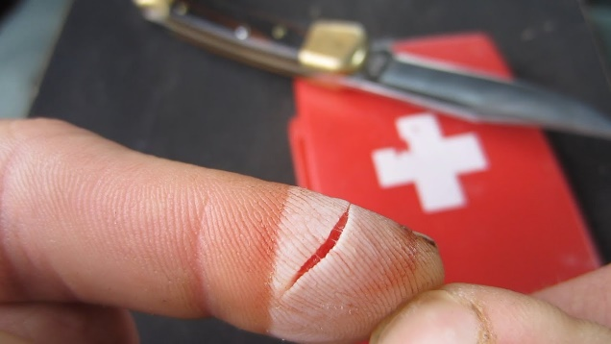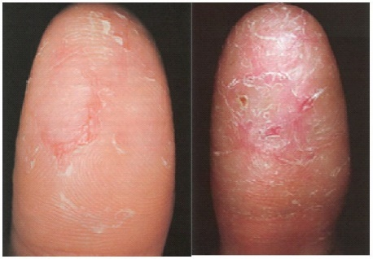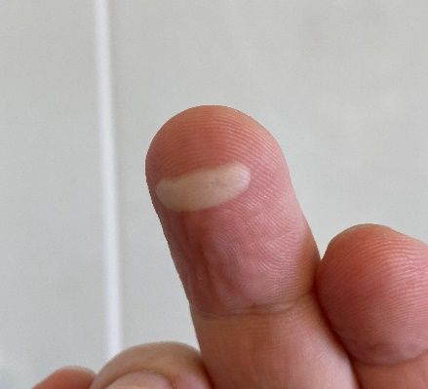Top of Form

Figure 1: Fingertip deep cut

Figure 3: Fingertip eczema

Figure 2: Fingertip burn blister

* 1. ***Testimonials from Real-World Cases***

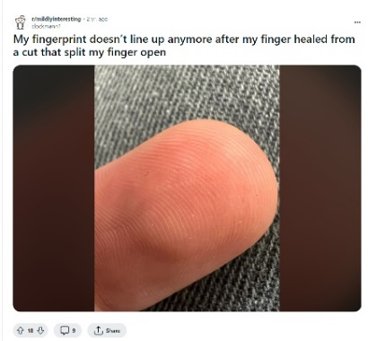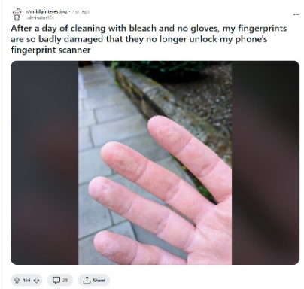While some may perceive it as insignificant, some real-world complaints are showcased in the following as testimonials to the severity of the problem at hand.

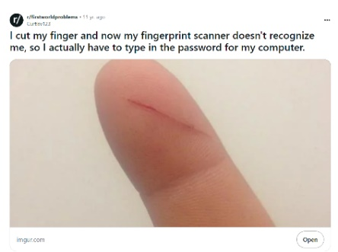

Figure 4: Some examples of people complains concerning the efficiency of biometric recognition systems after accidents

* 1. ***Research questions:***

Therefore, it is essential to comprehensively understand the impact of such damage on recognition algorithms' performance to strengthen the reliability and efficacy of biometric systems in real-world scenarios. Thus, the present project follows two main goals:

* Firstly, quantifying the impact of pathological conditions on fingerprint recognition algorithms
* Secondly, investigating whether damaged portions of fingerprints can be effectively regenerated using data from healthy regions, thereby enhancing the precision of biometric identification systems from a biological perspective.Top of Form

**Top of Form**

Two sub questions can also be defined as following:Top of Form

* Are there any discernible differences in fingerprint characteristics, such as ridge density, ridge patterns, and ridge minutiae between males and females? (we can use segmentation maybe to answer this)
* If yes, can they be utilized to refine the accuracy of gender-specific biometric identification systems?

1. ***Materials and Methods***
   1. **Dataset**

References:

<https://www.intechopen.com/chapters/39012>